**Programming Challenges 4 May 23, 2019 - Due on or before Midnight May 23, 2019**

**Objective:** C++ string class

|  |
| --- |
| **Important instructions:**   * *All programs must include comments at the top of your program: your name, course name-section number (CS 575), program name and the program description in brief.* * *Copy and paste your program code and outputs in Part B of each program.* * *Once it is done, save and submit this word file via Canvas.* |

To receive full credit, your program must:

- Include simple, clear comments explaining your program logic

- Indent your code and line up your braces

- Give descriptive variable names

- Use name constants wherever possible. Name constant must declare with CAPITAL.

- You must submit two outputs.

The first input string to test must be the same as one of two given sample outputs.

The second input string to test must be your own make-up string.

1. **WordSeparator.cpp**

Write a program that accepts an input as a sentence in which all of the words are run together (no space), but the first character of each word is uppercase. Convert the sentence to a string in which the words are separated by spaces and only the first word starts with an uppercase letter.

Make sure to submit two outputs and use the following function prototype:

**string split(string);**

**Sample output 1:**

Enter a sentence: SheSellsSeaShellsOnTheSeaShore

The new sentence: She sells sea shells on the sea shore

**Sample output 2:**

Enter a sentence: TheButterSheBoughtWasABitBitterAndMadeHerBatterBitter

The new sentence: The butter she bought was a bit bitter and made her batter bitter

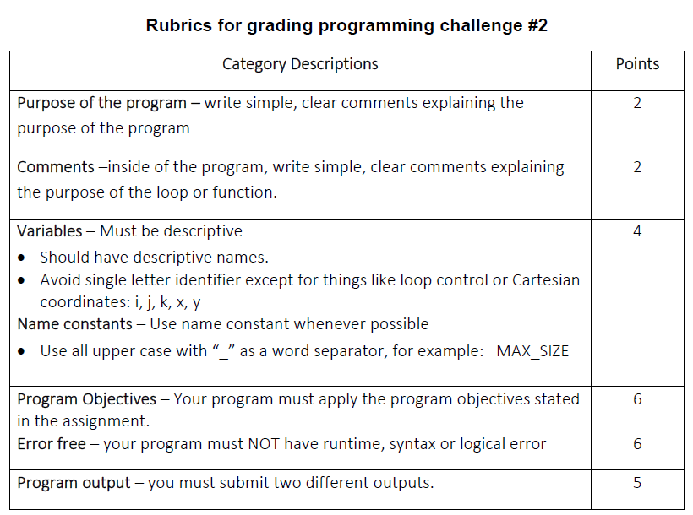

**Copy and paste your program (source) code and the outputs after this line**

**+++++++++++++++++++++++++++++++++++++++++++++++++**

/* Erik Gonzalez

CO SCI 575

WordSeparator.cpp

In this program the user enters a sentance but the words have no spaces

inbetween and each new word has to start with a captial letter. The program

then proceeds to seperate, and lowercase every word. The only capital will

be the first character in the string. */

#include <iostream>

#include <string>

using namespace std;

string split(string);

int main()

{

string sentance;

cout << "Enter a sentance: ";

cin >> sentance;

cout << "\nNew sentance: " << split(sentance) << endl;

system("Pause");

return 0;

}

string split(string split)

{

int stringLength = split.length();

int loopBreak = stringLength * 2;

int i = 1;

/* This loop skips the first character then lowercases each word with an uppercase

character and then puts a space inbetween that character and the previous one

before it. */

while (i != loopBreak)

{

i++;

char c = split[i];

if (isupper(c))

{

split[i] = tolower(split[i]);

split.insert(i++, " ");

}

else if (islower(c))

{

i++;

i--;

}

else

{

i = loopBreak;

}

}

/* This loop only accounts for the first character in the sentance

and if it is lowercase it'll proceed to uppercase it. If the

character is already uppercase it will ignore it. */

for (int i = 0; i < 1; i++)

{

char c = split[i];

if (islower(c))

{

split[i] = toupper(split[i]);

}

}

return split;

}

**OUTPUTS:**

**Enter a sentance: SheSellsSeaShellsOnTheSeaShoreTheButterSheBoughtWasABitBitterAndMadeHerBatterBitter**

**New sentance: She sells sea shells on the sea shore the butter she bought was a bit bitter and made her batter bitter**

**Enter a sentance: WhatAboutTheDroidAttacksOnTheWookies**

**New sentance: What about the droid attacks on the wookies**